project report

Patient Fees System

AYESHA MAJID

221019

**HOW DOES THIS PROGRAM WORKS?**

**CLASSES**

The different components (classes) of the program are

* The Patient Account class
* The Surgery class
* The Pharmacy class
* The main program

**Explanation Of Classes**

1. **Patient Account Class**

* The Patient Account class keep a total of the patient’s charges.
* It also keep track of the number of days spent in the hospital.
* The group must decide on the hospital’s daily rate.

1. **Surgery Class**

* The Surgery class have stored within it the charges for at least five types of surgery.
* It can update the charges variable of the Patient Account class.

1. **Pharmacy Class**

* The Pharmacy class will have stored within it the price of at least five types of medication.
* It can update the charges variable of the Patient Account class.

**Main Program**

* The main program consists of a menu that allows the user to enter a type of surgery and a type of medication
* Check the patient out of the hospital. When the patient checks out, the total charges should be displayed.

**OUTPUT**

* The output consists for surgery type.

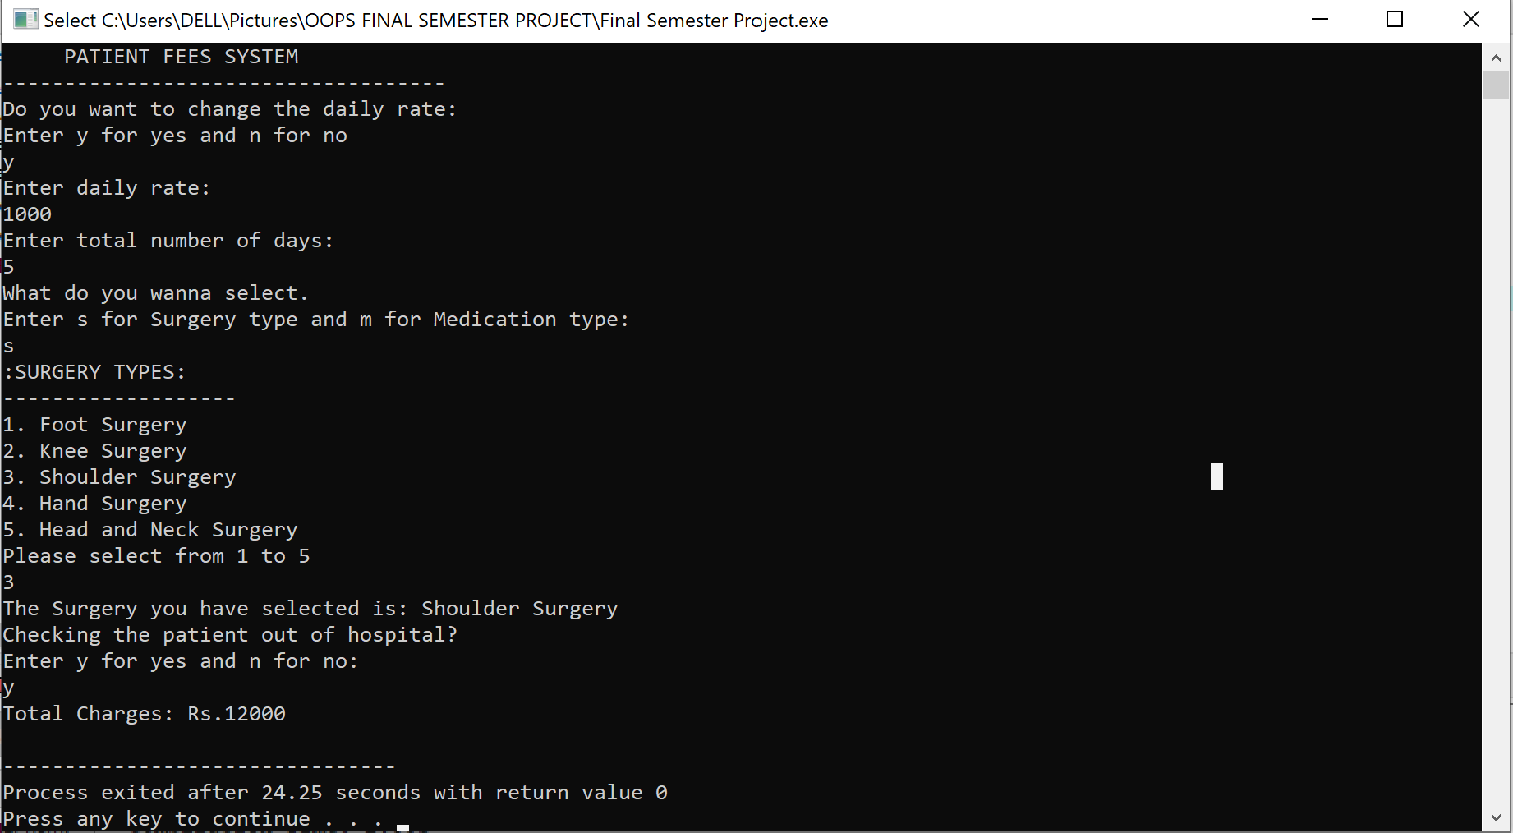

* The output consists for medication type.

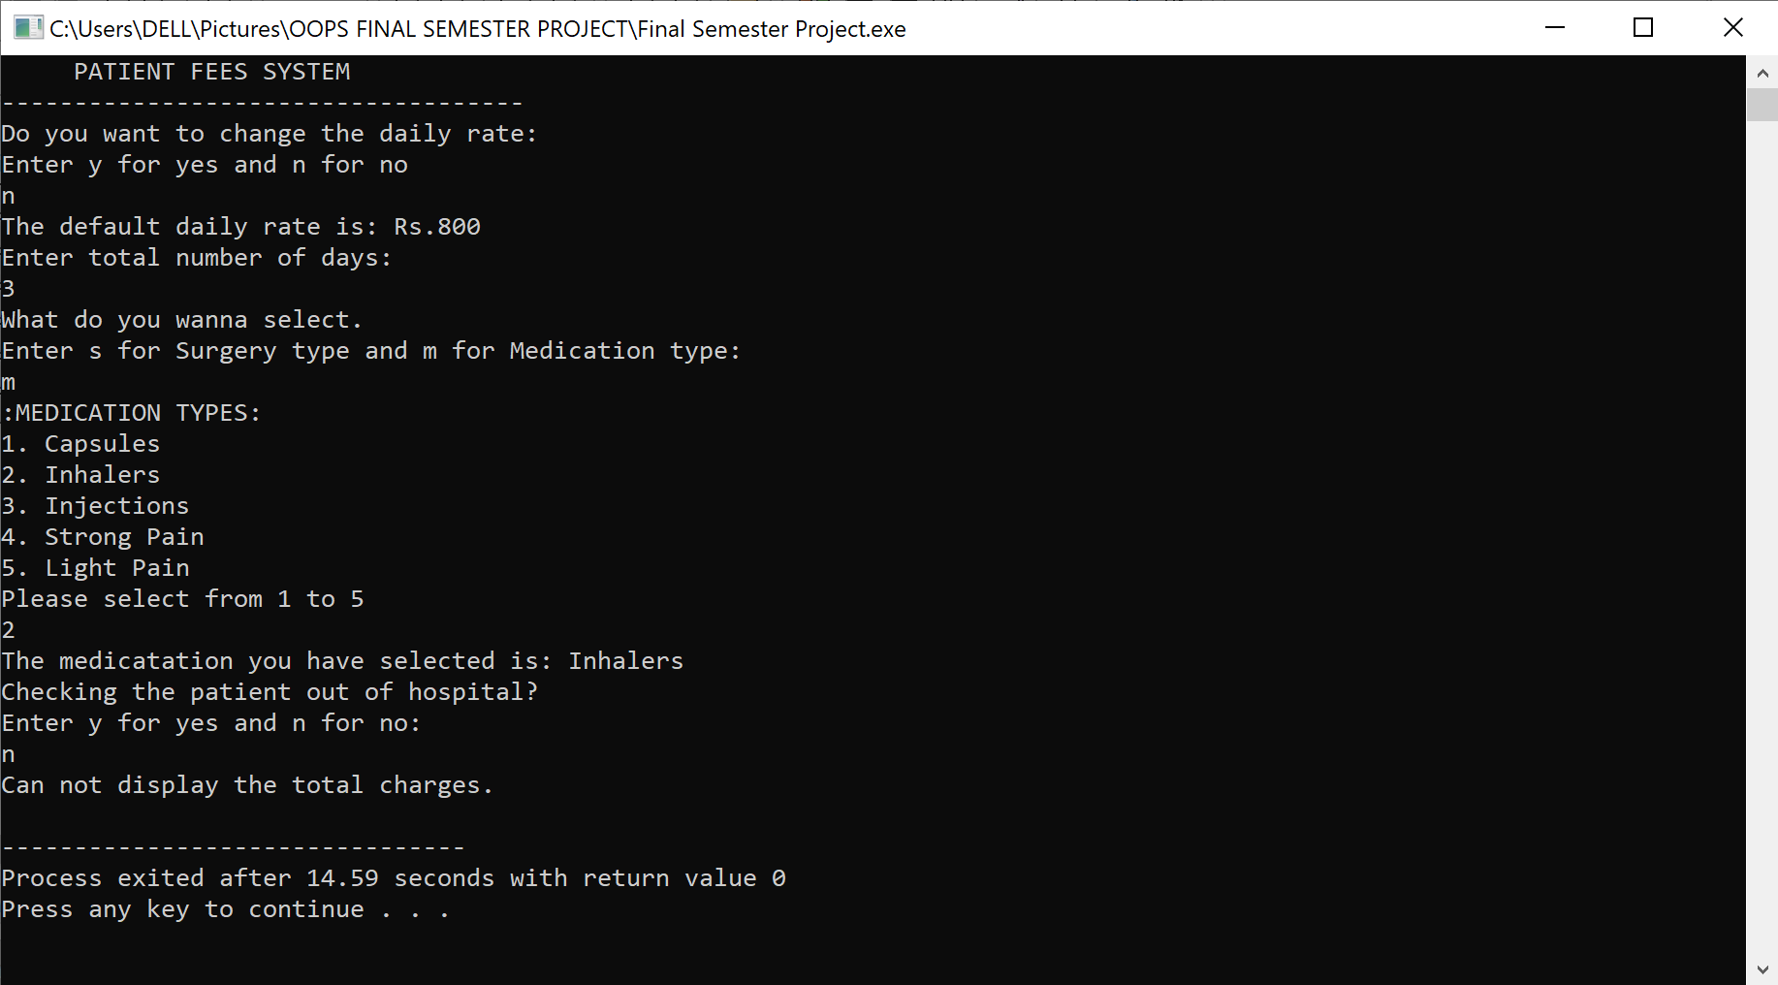

**SOURCE CODE**

**Patient Account Class**

**.h File**

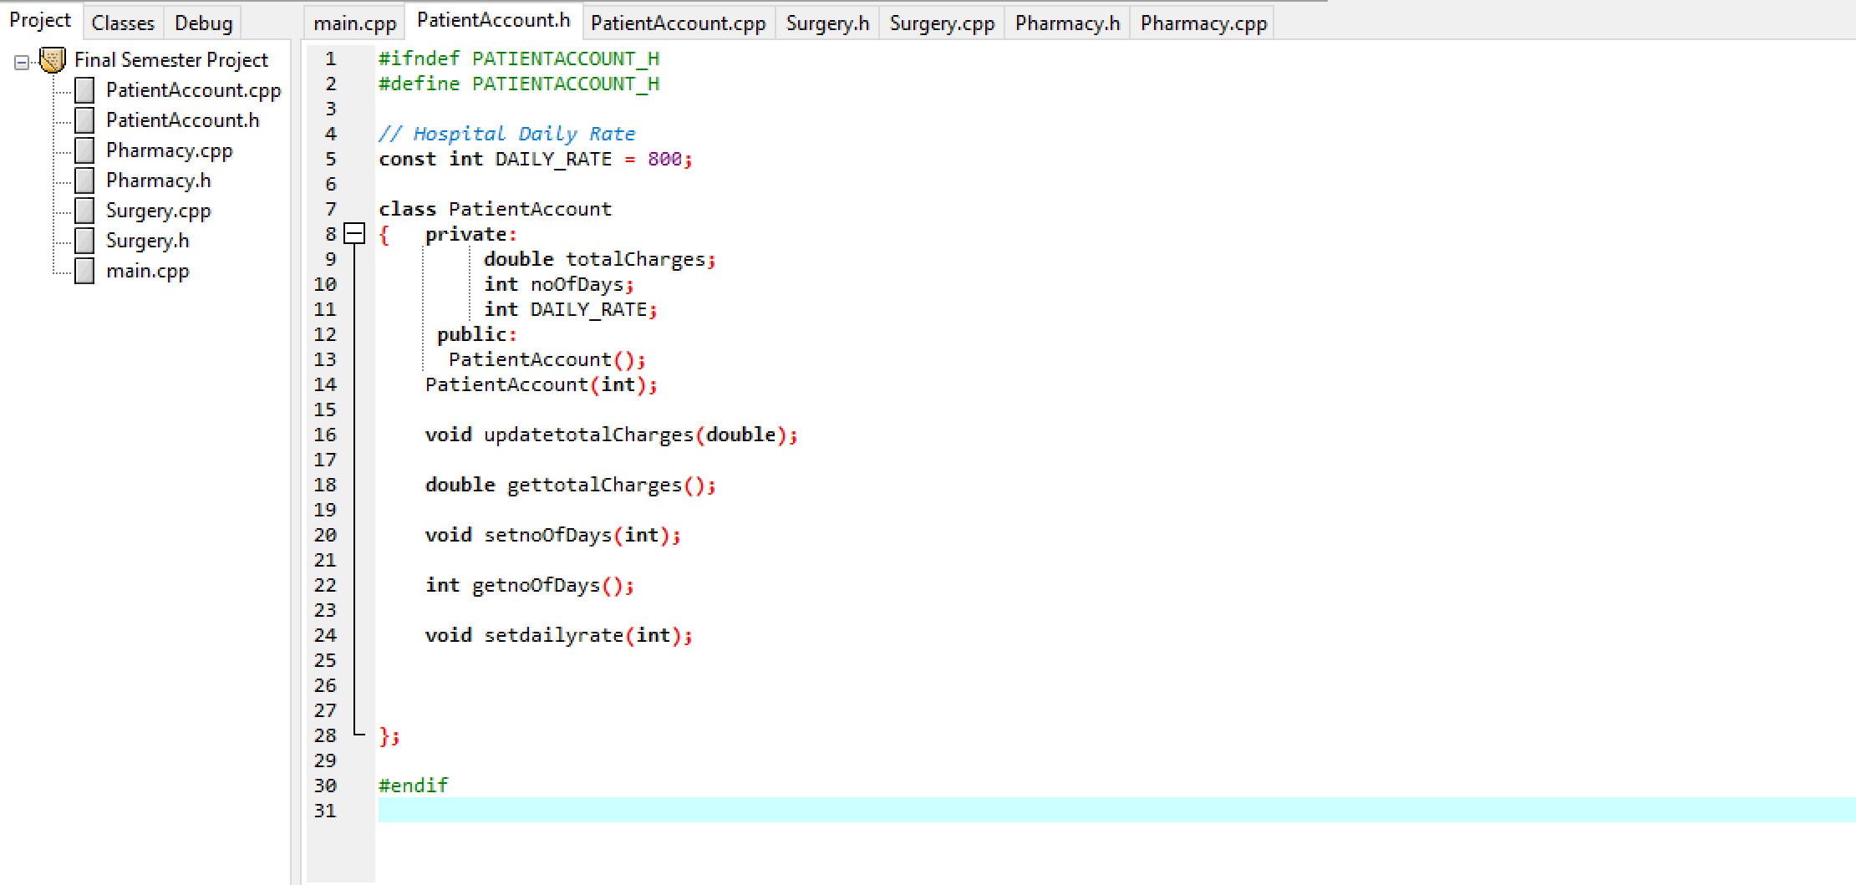

**.cpp File**

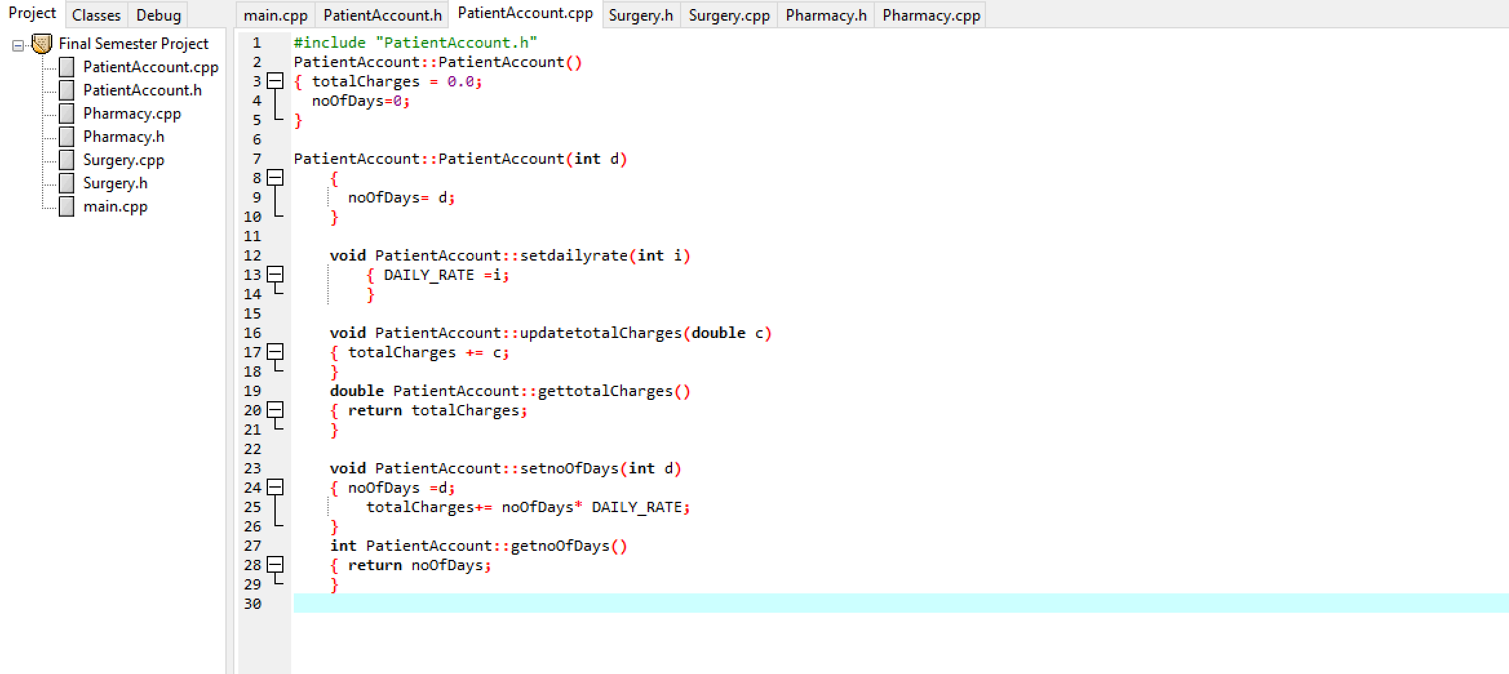

**Surgery Class**

**.h File**

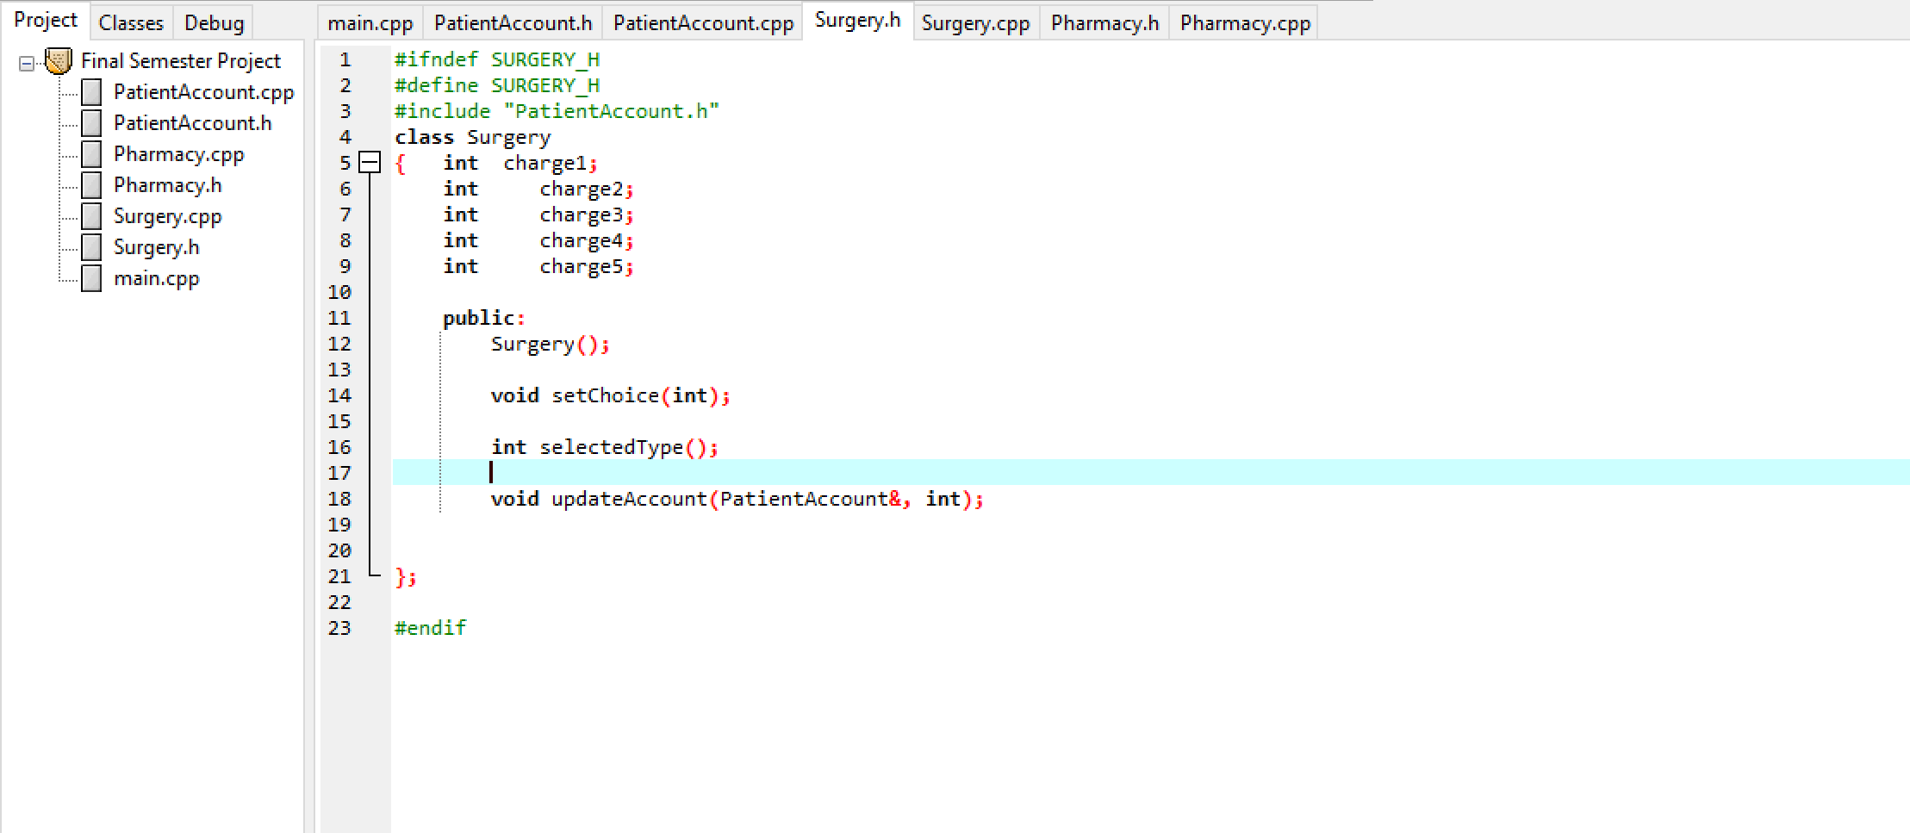

**.cpp File**

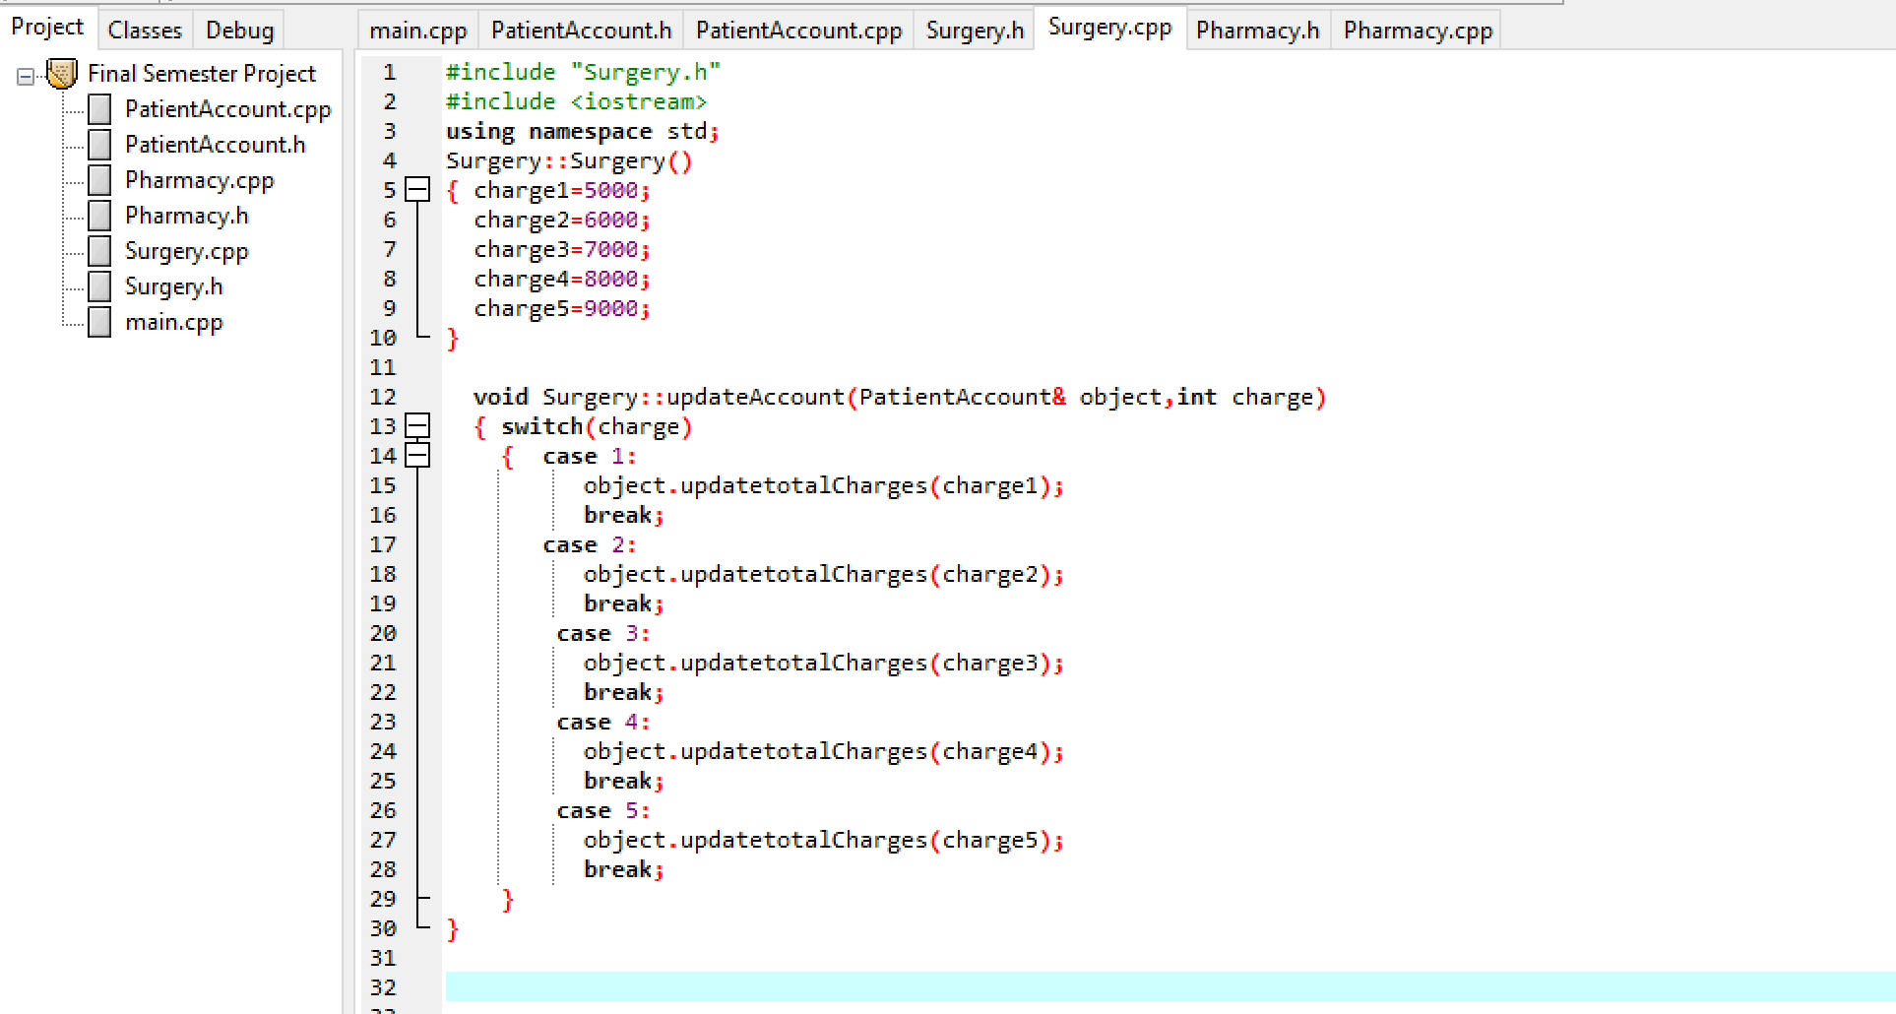

**Pharmacy Class**

**.h File**

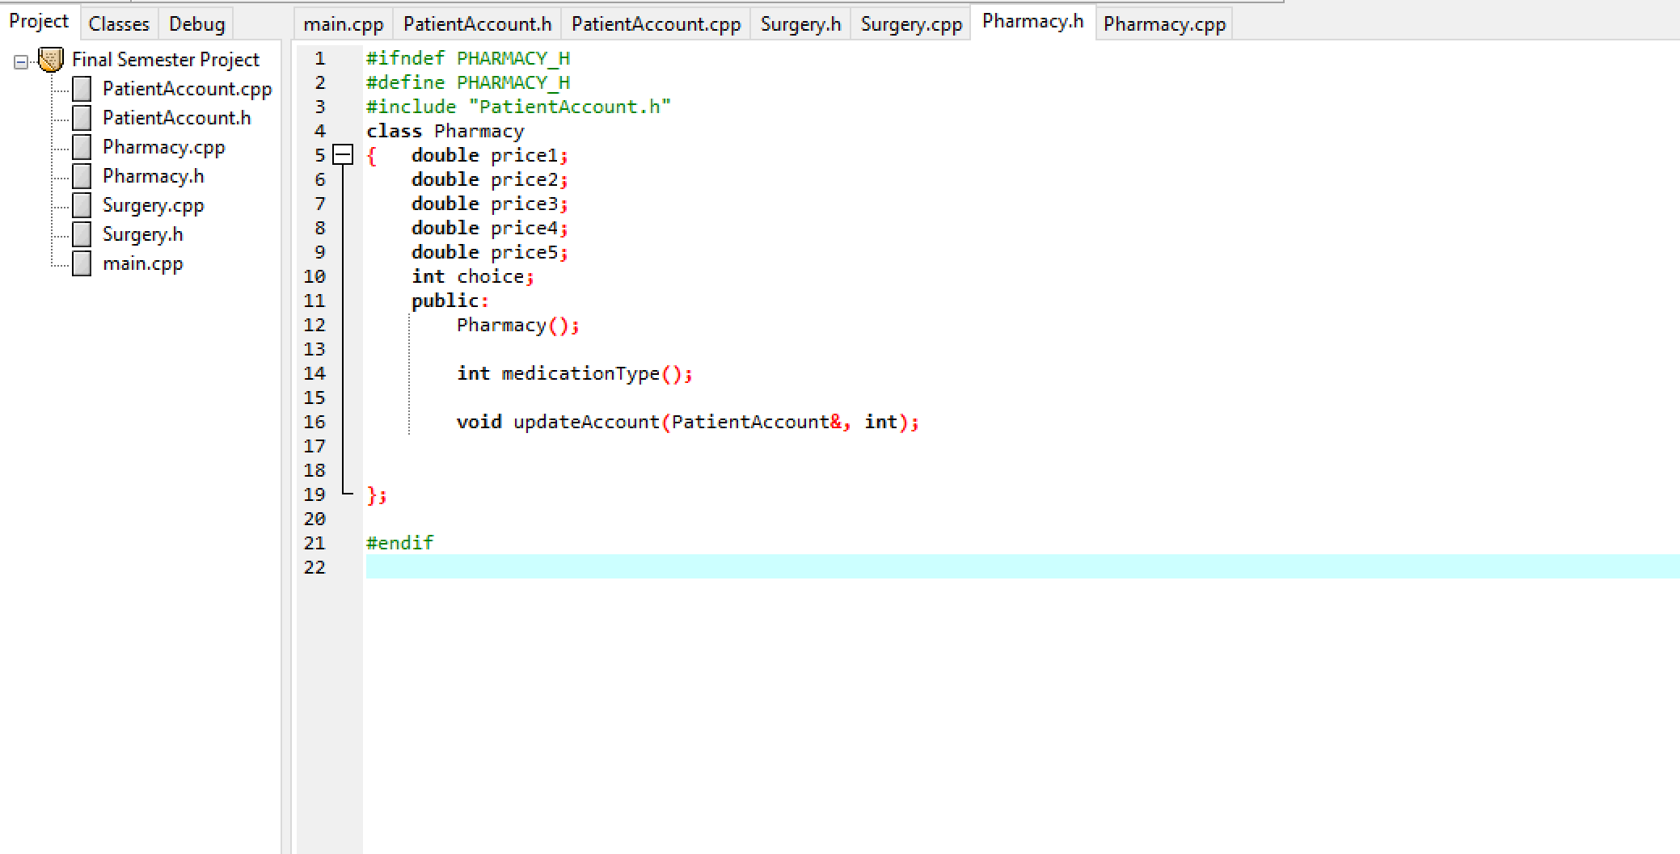

**.cpp File**

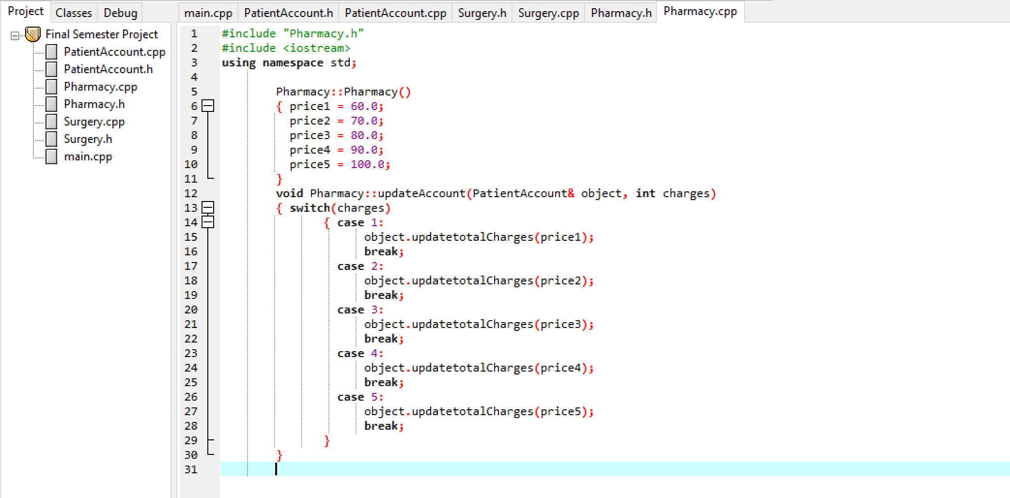

**Main Program**

